STUDY REPORT FOR:

FOOT-OPERATED DOOR OPENER TO ELIMINATE THE DOOR HANDLE AS A SOURCE OF CONTAMINATION:

Aim: As door handles represent a transmission route for viruses and micro-organisms, a door opening and closing mechanism should be developed without manual operation.

Method: To solve the problem, a device for opening the door with the help of a foot pedal was built into the door leaf.

Results: The design enables mechanical opening of the door with a foot Germany pedal without manual operation. Subsequently, the door closes with
the help of a mechanical locking mechanism.

Discussion: The foot-operated door opener constitutes an additional option to the door handle. Together with the equipment of a soft closing mechanism, it is possible to prevent noise emanating from the door latch impinging on the door frame. Using this construction, the door handle as a transmission vector is eliminated. In addition, the transport of goods held with two hands simultaneously is facilitated.

Conclusion: With a foot-operated door opener instead of the traditional manual door handle, it is possible to open doors with a foot pedal. This prevents contamination of door handles with pathogens.

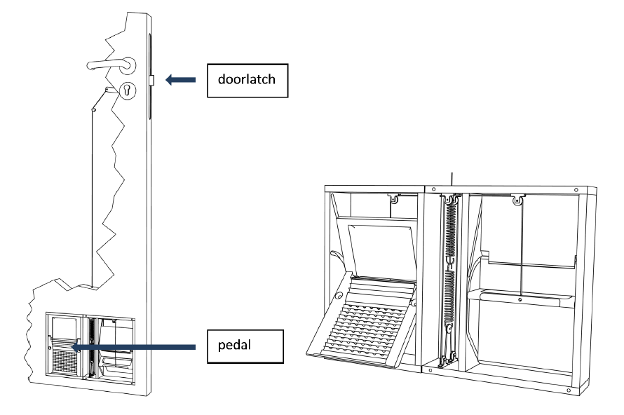

Door opener with hand or foot operation

A device for opening the door with the foot was fitted flush into the door leaf. A pedal (Figure 1) is integrated into the device, which is built into the bottom of the door leaf. To open the door, this pedal is pulled out with the foot from the inside of the device, while the foot constantly remains on the surface of the pedal. After completely pulling the pedal out, the door can be pushed open or pulled open while keeping light pressure on the pedal with the foot. The surface design of the pedal provides the necessary grip of the shoe on the pedal during the movement to be executed. Subsequently, the door will briefly remain in the open position before the door closer starts to pull the door back into its frame.

Using the foot pedal alone, this device makes it possible to open the door without manual operation. After opening of the door, there is time to pass through the open door. The foot-operated door opener is optionally
equipped with a soft-closing mechanism. As a result, while opening the door with the foot door opener, the door latch will be kept inside the door lock by a mechanism integrated into the foot door opener. Only after complete closing of the door (i.e., the door is back in its frame) is the door latch released by the mechanism: the door latch slowly and quietly returns to its normal position in the counterpart within the door frame.

The foot-operated door opener constitutes an additional option to the door handle. The function of the door handle and the door lock itself is not affected. In both cases, opening with the door handle and foot-operated door opener, the door latch is triggered, which means a change in the mechanics of the normal door handle with its lock is not necessary. Only if the door lock itself is locked is it impossible to open the door with either the handle or the foot door opener. Equipped with the soft closing mechanism, the noise generated by the door latch hitting the door frame is completely prevented, and the noise generated by the door latch quickly snapping back into its counterpart in the door frame is almost imperceptible. The foot door opener makes the door handle superfluous in most cases. This eliminates the risk of contamination
by pathogens potentially adherent on the door handle. In addition, the transport of items that must be carried with both hands, e.g., trays, is facilitated. Another means of opening doors without using the hands is provided by door handles designed to be operated with the forearm. However, this type of handle can still be operated by hand and is thus in danger of becoming contaminated. Nevertheless, when used correctly, the forearm-operated door opener reduces the risk of cross infection.

Additional advantages include:
• No electrical energy is necessary for operation
• No follow-up costs arise, e.g., from consumables
• The functionality of the existing door lock is not compromised, and
• Nothing protrudes from the plane of the door leaf.

